B.K. Jewellers

**Function Requirement Specification (FRS)**

**Document for**

**“Account management” department.**

Document NO: 001

Date: 10-02-2020

Prepared by:

Group 2

* **Revision History**

|  |  |  |  |
| --- | --- | --- | --- |
| **Revision Number** | **Revision Date** | **Summary of changes** | **Author** |
| **1** | 10/02/2020 | Document made. | Rudra soni |
| **2** | 18/04/2020 | * **Table of content:** Page numbers added. * (**2.1 &2.2 IMAGE**)**:** Indicators added. * **(2.1 &2.2 all elements):** Button state (active) added. | Rudra soni |
| **3** |  |  |  |
|  |  |  |  |

* **Table of Contents** -

|  |  |  |
| --- | --- | --- |
| Sr.  No. | Content | Page  No. |
| 1. | Introduction |  |
|  | * 1. Objective | 4 |
|  | 1.2 Scope | 4 |
|  |  |  |
| 2. | Functional Description |  |
|  | 2.1 Accountant | 4 |
|  | 2.2 Account manager | 9 |
|  |  |  |
| 3. | System hardware | 13 |
|  |  |  |
| 4. | Security | 13 |
|  |  |  |
| 5. | Regulatory requirement |  |
|  | 5.1 Accurate record generation | 13 |
|  | 5.2 Timeouts | 14 |
|  | 5.3 Operational system checks | 14 |
|  | 5.4 Electronic signature manifestation | 14 |
|  | 5.5 User password controls | 14 |
|  | 5.5.1 Password expiration | 14 |
|  | 5.6 Additional system controls | 15 |
|  | 5.6.1 Event logging | 15 |
|  | 5.6.2 System access | 15 |
|  | 5.6.3 Input checks | 15 |

1. **Introduction**
   1. Objective:

This is the functional requirement specification (next will be written as FRS) for “Account” functionalities used by Account department of **B.K. Jewellers.**

The FRS is details the capabilities and functions that the software must be capable of and reliably perform functionalities.

* 1. Scope:

This document applies to the “Account department” of software. The document will address the functions of “Account department” must be able to successfully perform primary business requirements. The focus is on what the “Account department” must do.

1. **Function description**
   1. Accountant

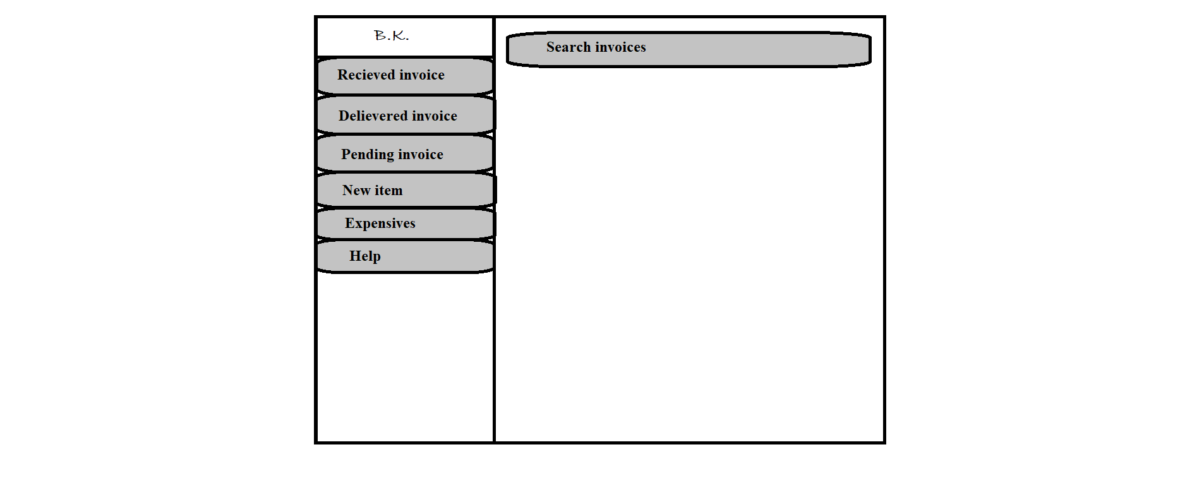

H

G

F

E

D

C

B

A

1. Logo

* Type: image
* Use: only for design
* Events: none
* Source: BKlogo.png

1. Received invoices

* Type: button
* Text on button: Received invoices
* Background colour(Active): gray
* Use: to enter the external (B2B & B2C) invoice values for maintaining record.
* Events:

click:- two text field will appear one for invoice number and second for sender name, one extra button for scan the invoice.

Hover:- display information (text) “External received invoice.” below mouse arrow.

* Functions:
* Automatic new entry generated.
* When button is clicked :- two text field will appear one for invoice number and second for sender name, one extra button for scan the invoice.
* After entering name of sender and invoice number, user scans the invoice.
* After scanning is completed file will be saved in folder named “External invoice”.

1. Delivered invoice

* Type: button
* Text on button: Delivered invoice
* Background colour(Active): gray
* Use: used to make a list of delivered payment invoices.
* Events:

click:- navigate user to preformatted invoice in edit mode.

Hover:- display information (text) “Delivered invoice.” below mouse arrow.

* Functions:
* When clicked user will navigate preformatted invoice in edit mode.
* Automatic invoice number generation.
* User will have to fill the name of receiver and amount.
* After entering all requirements user will have to press submit button placed at bottom-right corner of window.
* A copy of invoice image will be saved to database.

1. Pending invoice

* Type: button
* Text on button: Pending invoice
* Background colour(Active): gray
* Use: to make user aware of pending works.
* Events:

click:- list of incomplete invoice generated by account manager will be shown in widow .

Hover:- display information (text) “Pending invoices.” below mouse arrow.

* Functions:
* Finding all invoices which have “pending” status.
* Display all invoices in list with invoice number as title.
* User can click on any invoice present in list, an image of invoice will be shown.
* When any pending invoice completes user change the status to “done” option available on right side of each and every result.
* The completed invoices will be removed from the result.

1. New item

* Type: button
* Text on button: New item
* Background colour(Active): gray
* Use: to add new jewellery item to stock.
* Events:

click:- a form for adding new item (source: newitem.xlsx)in stock is shown.

Hover:- display information (text) “add new item.” below mouse arrow.

* Functions:
* A form for adding new item (source: newitem.xlsx) in stock is shown.
* Enter all basic values (category, net weight, gross weight, labour, method of manufacturing and image) of new item and then apply GST charges on it.
* Automatic final price of item is calculated and display at respective place.
* When all details have been entered user clicks submit button and this item will be added to main branch’s stock.

1. Help

* Type: button
* Text on button: Help
* Background colour(Active): gray
* Use: to acknowledge the user.
* Events:

click:- a help page (source: help.docx)will appear which contains all information of every single step.

Hover:- display information (text) “help.” below mouse arrow.

* Functions:
* When button is clicked help.docx page will appear in full window.

1. Search

* Type: Search bar
* Placeholder: Search..
* Use: search any invoices and items.
* Events:

click:- activate keyboard for input.

* Functions:
* When user click on search bar keyboard will be activated for input.
* When “Enter” button is clicked after any invoice number or item code is entered software will search matching data from database and show all details and last operation done on item in new window.
  1. Account manager

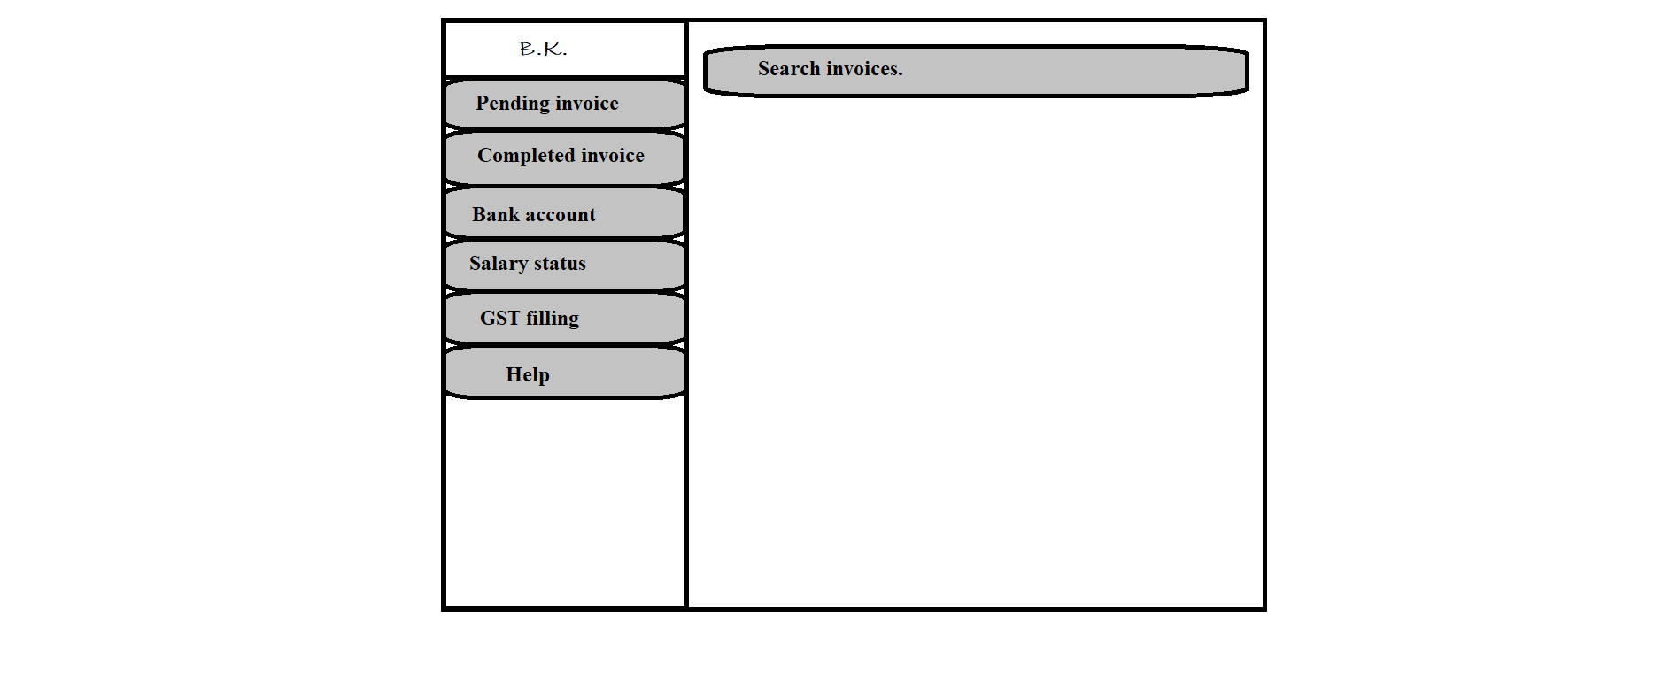

1. Logo

* Type: image
* Use: only for design
* Events: none
* Source: BKlogo.png

1. Pending invoice

* Type: button
* Text on button: Pending invoice
* Background colour(Active): gray
* Use: to make user and accountant aware of pending invoices.
* Events:

click:- finding al invoices which ha status “incomplete”.

Hover:- display information (text) “pending invoice.” below mouse arrow.

* Functions:
* Finding all invoices which have “pending” status.
* Display all invoices in list with invoice number as title.
* User can click on any invoice present in list, an image of invoice will be shown.
* When any pending invoice completes user change the status to “done” option available on right side of each and every result.
* The completed invoices will be removed from the result.

1. Completed invoice

* Type: button
* Text on button: completed invoice
* Background colour(Active): gray
* Use: display all completed invoices.
* Events:

click:- show all invoices which have status “completed”.

Hover:- display information (text) “completed invoice.” below mouse arrow.

* Functions:
* Finding all invoices which have status “completed”.
* When button is clicked user will see all invoices in list format which contains last one at the top.
* Title has been set as invoice number.

1. Bank account transactions

* Type: button
* Text on button: Bank account
* Background colour(Active): gray
* Use: to keep record of all bank activities.
* Events:

click:- a MS Excel sheet (source: banktransaction.xlsx) will be opened which is formatted for keeping records.

Hover:- display information (text) “bank account transactions sheet.” below mouse arrow.

* Functions:
* When button is pressed, a MS Excel sheet (source: banktransaction.xlsx) will be opened which is specially formatted only for keeping records of each and every banking activities.

1. Salary status

* Type: button
* Text on button: Salary status
* Background colour(Active): gray
* Use: to keep record of monthly salary of every employee.
* Events:

click:- a MS Excel sheet (source: salary.xlsx) will be opened which is formatted for keeping records.

Hover:- display information (text) “salary status sheet.” below mouse arrow.

* Functions:
* When button is pressed, a MS Excel sheet (source: salary.xlsx) will be opened which is specially formatted only for keeping records of salary of each and every employee.

1. Online GST return filling

* Type: button
* Text on button: GST filling
* Background colour(Active): gray
* Use: to fill GST online.
* Events:

click:- opens the GST filling website ([www.gst.gov.in](http://www.gst.gov.in)) and minimise the software.

Hover:- display information (text) “GST return.” below mouse arrow.

* Functions:
* No any function for this process.

1. Help

* Type: button
* Text on button: Help
* Background colour(Active): gray
* Use: to acknowledge the user.
* Events:

click:- a help page (source: help.docx)will appear which contains all information of every single step.

Hover:- display information (text) “help.” below mouse arrow.

* Functions:
* When button is clicked help.docx page will appear in full window.

1. Search

* Type: Search bar
* Placeholder: Search...
* Use: search any invoices and items.
* Events:

click:- activate keyboard for input.

* Functions:
* When user click on search bar keyboard will be activated for input.
* When “Enter” button is clicked after any invoice number or item code is entered software will search matching data from database and show all details and last operation done on item in new window.

1. **System hardware**

The software can run on the minimum standard PC workstation or laptop configuration by **B.K. Jewellers.** This part can be accessible by all PC present in workgroup of organization for “Account”.

This part of the software does not affect the organization LAN.

1. **Security description**

The account part is only accessible through the software provided by “BlackSky Systems.” This software or any part of the software does not open from outside the configured environment of **B.K. Jewellers.**

1. **Regulatory requirements**
   1. Accurate record generation:

It has ability to generate accurate and complete record in both human readable and electronic form suitable for inspection & review by regulatory agencies.

The functionality meets the following requirements:

* The ability to generate accurate and complete copies of record in both human readable and electronic form suitable for inspection & review by the agency.
* Users are able to select search queries.
* Users are not able to customise criteria used to view data from search.
* Users are able to export data through MS Excel
  1. Timeouts:

The software for “Account department” will not automatically time-out, it is supposed to run after login till the user won’t logout from the system.

* 1. Operational system checks:

The “Account department” software uses operational system checks for enforce permitted sequencing of steps and events.

* 1. Electronic signature manifestation:

The software has secure data in system through electronic signatures. Data secured with an electronic signature cannot be edited or deleted unless the signature is removed.

* 1. User password controls:

This software does not allow user to change their passwords. Only the administration has this authority.

5.5.1 Password expiration:

Once the password is created it never expires unless user requested to change it.

* 1. Additional system controls:

5.6.1 Event logging:

It includes system login and logout, as well as attempts failures.

5.6.2 System access:

Access to software must be controlled by user access to the LAN controlled by system identification and password.

5.6.3 Input checks:

When appropriate entries may programmatically checked before being accepted by software.(for example, No negative values accepted for item price.)